 **|| Hare Krishna||**

**BIODATA**

**Name : -** Swapnil Uddhavrao Adyalkar

**Date of Birth : -** 06 March 1990

**Birth Time : -**10:45 AM

**Place of Birth : -**Sindi (Railway) , Wardha District, Maharashtra, India

**Height : -**5 Feet 10 Inch

**Birth Name : -**Chhagan

**Sign : -**Gemini

**Education : -** Bachelor of Engineering in Electronics & Communication

Pursuing DevOps Certification

**Occupation :-** Engineer in IT / Telecom Sector

**Annual Salary pkg : -** 5 to 6 LPA

**Part Time Business: -** **:-** VLCC Online Services Pvt. Ltd.

**Kul :-** Ninave

**MamKul :-** Parate

**Caste** :- Halba, Koshti

**Brother & Sister : -**1 brother (Married) , NO Sister

**Permanent Address : -**Plot No. 28, Ward No. 06, Wanadongri, Hingna Road, Nagpur, MH, 441110

**Current Company Name : -** Reliance Jio Infocomm Ltd

**Designation & Position :-** Deputy Manager **&** State VVM Core Engineer.

**Job Location : -** Reliance Jio Data Center, Mauda, Bhandara Road, Nagpur, Maharashtra

**Diet :- Pure Vegetarian**

**Contact No. :- 9359486598 / 8855071097**

**Spiritual Life: - Daily Approx. 8 Time Japa., Sometime 16 Round**

**ISKCON Join Period: - 1.5 Year**

**Book Reading: - Shree Mad Bhagwat Gaeta**

**Note:-Wedding Destination Will be Uttarakhand, ISKCON Temple (Dehradun) or Triyuginarayan Temple** [Rudraprayag district](https://en.wikipedia.org/wiki/Rudraprayag_district), [Uttarakhand](https://en.wikipedia.org/wiki/Uttarakhand),



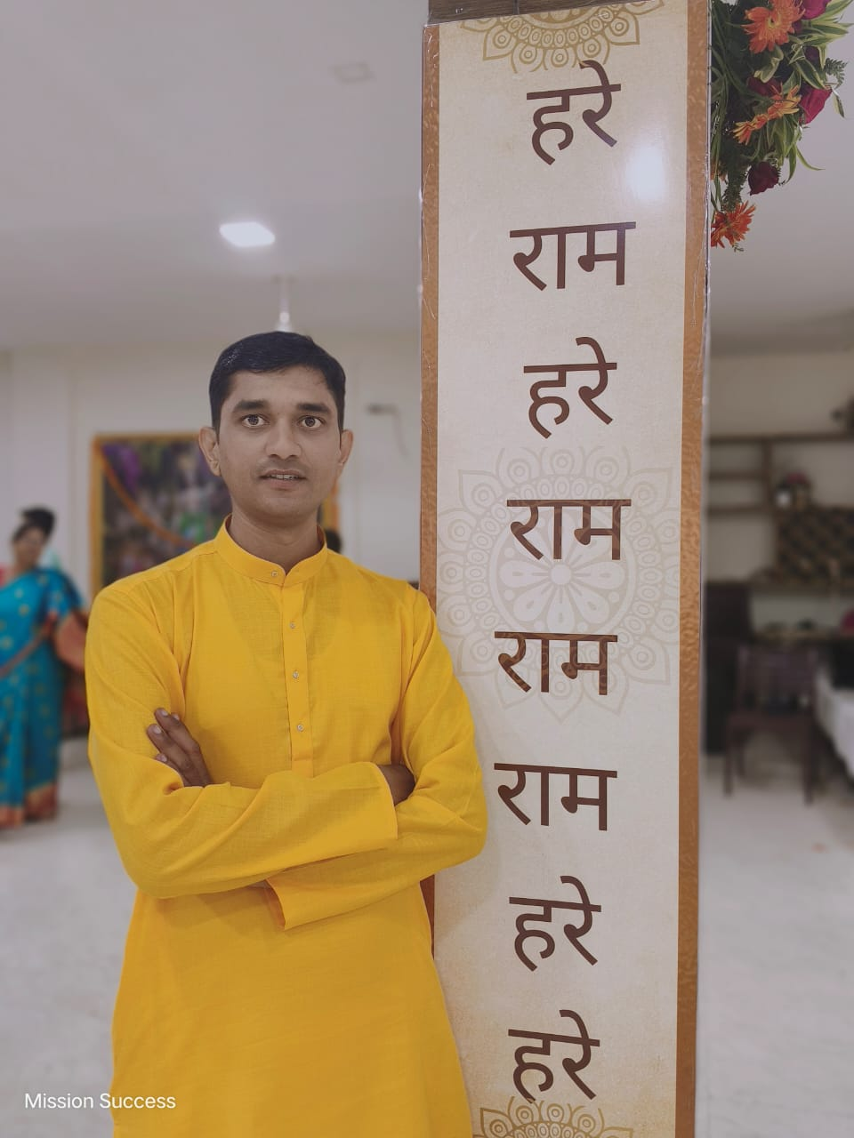

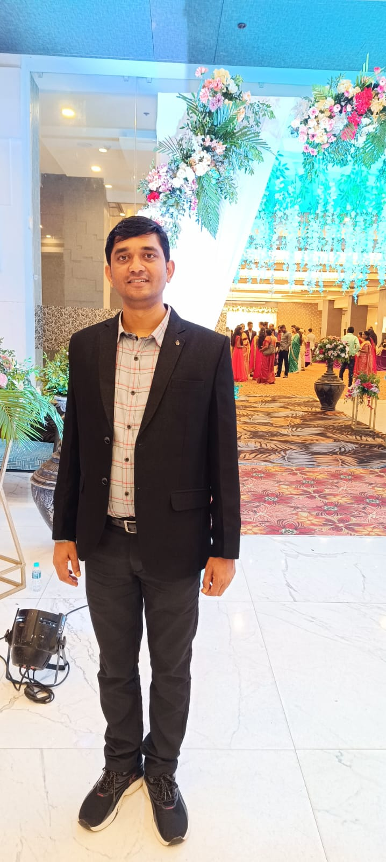

[](https://www.amarujala.com/astrology/horoscope/gemini-daily-horoscope)

